Lecturer’s name: N/A | Date: Day 7
Course: Math | Unit: Equivalent Forms of Fractions, Decimals, and Percents
Unit Duration: 10 days | Lesson Duration: 1 day
TEKS: 6.1A, 6.1B, 6.1C, 6.1D | Lesson Part 1
Topic: Review + Online Quiz

Lesson objectives:
- SWBAT use the percent equation strategy to solve percent problems.
- SWBAT use multiple strategies to solve percent problems and identify the strategy that is most efficient for a particular problem.
- SWBAT to take the unit online quiz

Essential Questions:
How can I use the percent proportion with real world problems?
What strategies can I use to find the different parts of a percent proportion?
What strategies can I use to take an online quiz?

LYS Methodology

Be (Character/Values/Principles) - Educational, Financial, Vocational, Spiritual, Cultural - How can I use the strategies in a percent proportion to figure out how to find other connected, responsible, and curious mentors in my life?

Know (What resources are available to the student/ How can they use them) - Educational and Health - How can I learn strategies for technological learning and apply those when networking or applying for internships/jobs in the future?

Do (Execute with Excellence) - Educational, Financial and Spiritual - How does tech knowledge best prepare me to be independent, resourceful, and professional in all future endeavors I decide to take on? Especially in this day in age.

Resources (Include Technology):
Instructional Input - Asynchronous
AS: Anticipatory Set (Introduction)
- Students warm up practice how to convert and compare percents, decimals and fractions
- Day7 Warm Up

M: Modeling (I do)
- Teacher models 1-2 problems from the following sets
- 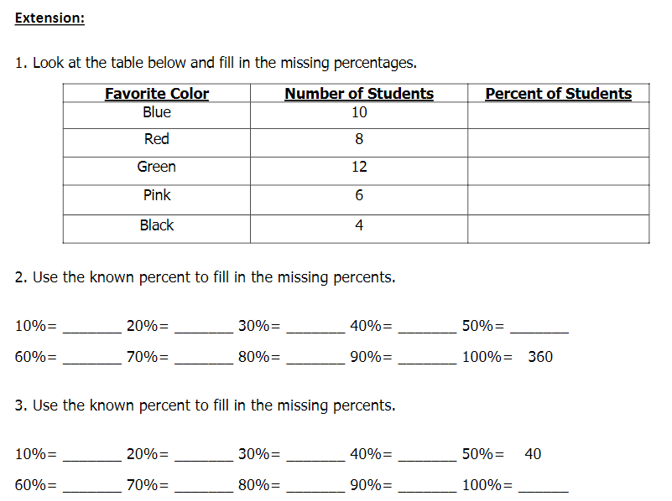
- Students complete the rest of the problems with their elbow partner
- Teacher bring back students to review answers

GP: Guided Practice (We do)
- Teacher reviews MC strategies with students BEFORE taking quiz
- Underline important words.
- Restate the question in your own words.
- Reread the test item, including all answer choices.
- Analyze and eliminate answer choices.
- Check your answer in the context of the problem.

Instructional Input - Synchronous
AS: Anticipatory Set (Introduction)
- Students warm up practice how to convert and compare percents, decimals and fractions
- Day7 Warm Up

M: Modeling (I do)
- Teacher models 1-2 problems from the following sets
- 
- Students complete the rest of the problems with their elbow partner
- Teacher bring back students to review answers

Independent Practice/ Homework
- Students complete online quiz that contains problems such as the following

- 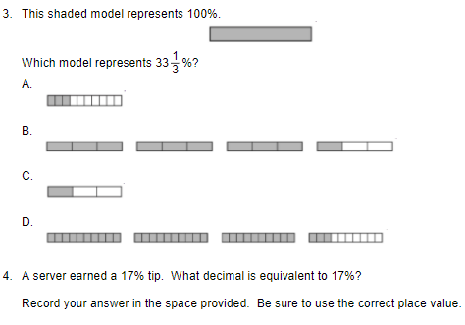

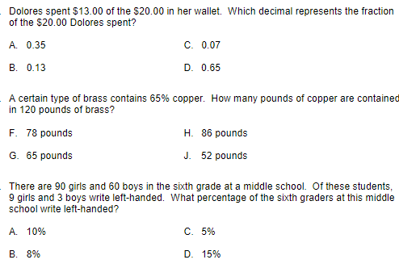

Lesson Close

Spiritual
“Technology is a useful servant but a dangerous master. ” - Christain Lous Lange

How can I learn strategies for technological learning and apply those when networking or applying for internships/jobs in the future?

Technology will be inevitable in this day in age. It will be important to learn how to navigate through various systems whether that is at school, home, socially and professionally. Most of your early technological usage will come from your house and your peers and teachers. There are many pitfalls when learning how to navigate various learning platforms. It will be important to learn these early on in order to be independent, resourceful and professional, especially when trying to find mentors, internships or scholarships for future goals.

